 |  | 
FreshFind - Project Documentation
TechWiz 7: eProject SRS Specifications & Complete Documentation Section Forms
1.
CERTIFICATE OF COMPLETION
This is to certify that : Shahzaib,Raheel,Hussain,Maaz,Sundal,Emaan
Has successfully Designed & Developed the project titled:
FreshFind - Local Farmers' Market Companion Portal (Theme: eGreen Basket)
Submitted by: DIGITAL TITAN
Date of Issue: September 25, 2026

2. Section 3.2: Customer Requirement Specification (CRS)
eProject Guide - Build Responsive NextGen Websites (Page 217)
Client: FreshFind Platform / Community Residents & Local Farmers
Business/Project Objective: To provide a lightweight, responsive, browser-based Single Page Application (SPA) that acts as a centralized local market companion. The platform enables community residents to discover nearby farmers' markets, operating schedules, interactive maps, seasonal produce guides, bookmark favorite items, and consult a pre-scripted AI chatbot without relying on server backend infrastructure.
Inputs provided by the Client:
- • Inputs to the System: Search/filter queries by neighborhood, area, day of the week, and produce category.
- • Outputs from the System: Filtered market directory cards, market detail view (schedules, maps, produce available), produce guide, floating AI chatbot responses, bookmark summary list, and interactive geolocation/clock status.
- • Process Involved in the System: JSON/TXT static data parsing, UI filtering and sorting logic, rule-based chatbot query processing, real-time 'Open Now' schedule calculations, bookmark session persistence, and social sharing links.
- • Expected Delivery Dates: As per TechWiz 7 eProject schedule / Submission Deadline.
- • List of Deliverables: Responsive SPA Website Source Code (ZIP), Project Documentation Report, UI/UX Design Assets, Test Cases & Report, ReadMe.doc, and Mandatory Working Video (.mp4).
Hardware Requirements: Intel Core i5/i7 Processor or higher, 8 GB RAM, SVGA Color Display, 500 GB HDD space, Keyboard, Mouse.
Software Requirements: Windows 10/11 OS, Visual Studio Code / HTML5 Editor, HTML5, CSS3, JavaScript, Bootstrap / Tailwind CSS, ReactJS or AngularJS, Local Data Store (JSON/TXT files), Web Browser (Chrome/Edge/Firefox).
Scope of the Work (in brief): Design and develop 'FreshFind', a responsive front-end web application that consolidates local farmers' market details, seasonal produce recommendations, rule-based AI chatbot assistance, and session bookmarking using pure client-side technologies and JSON data sources.
3. Customer Requirement Specification (CRS)
eProject Guide - Build Responsive NextGen Websites (Page 230 Adaptation)
Client: FreshFind - Local Farmers' Market Companion
Business/Project Objective: To establish a centralized digital platform that connects community residents with local farmers' markets, facilitating easy access to market schedules, locations, seasonal produce, and scripted chatbot assistance.
List of inputs to the system:
Inputs would include search criteria (location/area, day of week) and produce filter criteria as specified by the user. Inputs can also be form inputs in the Contact Us section and custom note inputs in the Content Bookmarking System.
List of outputs expected from the system:
Outputs would include dynamic lists of farmers' markets being offered in the area, detailed schedules and interactive map locations, produce guide catalogs, real-time 'Open Right Now' highlights, and pre-scripted chatbot answers.
Overview of processes involved in the system:
- Market Directory & Schedule Browsing (loaded from JSON/TXT files)
- Produce Guide & Seasonal Recommendation Matching
- Pre-Scripted Rule-Based AI Chatbot Query Processing
- Content Bookmarking and Session Note Management
Hardware and software required for implementing the project:
The hardware required would be a system with Intel Core i5 Processor or higher, 8 GB RAM or above, Color SVGA, and 400 GB Hard drive space. The software required includes Windows 10 or higher, Visual Studio Code / Notepad++, HTML, CSS3, JavaScript, Figma, and ReactJS or AngularJS. In order to run the Website, a modern Web browser is required. JSON files act as the lightweight static data store.
Acceptance criteria for the project:
- Multi-section responsive navigation: Market Directory, Produce Guide, AI Chatbot, Bookmarks, Contact Us, and About Us
- Easy dynamic sorting and searching across markets and seasonal produce
- Full mobile and desktop responsiveness without layout breaking
- Smooth cross-page access for Search, Bookmarks, and AI Chatbot
- Visually appealing UI adhering to the 'eGreen Basket' fresh eco-theme
4. Section 3.1: Problem Definition
Problem Definition: Information regarding local farmers' markets—such as operating schedules, exact locations, vendor lists, and seasonal produce availability—is currently fragmented across printed flyers, social media groups, physical community boards, and word-of-mouth. Residents lack a unified, reliable digital platform to plan their market visits effectively.
- 1. Lack of Centralized Information: Inability for residents to verify whether a farmers' market is open on a specific day or time, leading to wasted trips.
- 2. Seasonal Produce Uncertainty: Shoppers often do not know which fruits and vegetables are currently in season or available at specific markets.
- 3. Poor Visibility for Local Growers: Local farmers and small market organizers struggle to reach local residents due to a lack of dedicated digital exposure.
- 4. Technical & Accessibility Barriers: Existing directories are complex or require heavy server backends, making them slow or inaccessible on mobile devices.
5. Architecture and Design of the Project
Figure 1.1 displays the application architecture for FreshFind:
- Frontend Layer: Client Browser (Desktop, Tablet, Mobile) running HTML5, CSS3, JavaScript, Bootstrap/Tailwind, and ReactJS/AngularJS.
- Data Storage Layer: Static Data Layer composed of pre-populated JSON/TXT data files (markets.json, produce.json, chatbot_faq.json). No server-side database or live external API backend is utilized, fulfilling all client constraints.
Figure 1.2 displays the Context Level Diagram (Level 0 DFD) of the application:
- FreshFind Website <--- (Market related information retrieved) ---> JSON_Markets Data File
- FreshFind Website <--- (Produce & seasonal guide retrieved) ---> JSON_Produce Data File
- FreshFind Website <--- (Pre-scripted FAQ & responses retrieved) ---> JSON_Chatbot Data File
6. Section 3.4: Data Flow Diagram (DFD Description)
A Data Flow Diagram (DFD) is a graphical representation of the flow of data through an information system. For the FreshFind project, the DFD illustrates how user queries (search terms, filters, category selections) flow into the client-side rendering engines, which retrieve and parse data from static JSON stores (`JSON_Markets`, `JSON_Produce`, `JSON_Chatbot`), and output formatted UI components to the user.
Figure 1.3: Home Page Navigation Flow (Activity Diagram)
The activity diagram below illustrates the routing logic from the FreshFind Home Page. On load, the Home Page presents the Classes, Information, Blog, Contact Us, and About Us options; the system evaluates each option in sequence and routes the user to the corresponding dashboard or page, ending the flow once a match is displayed.
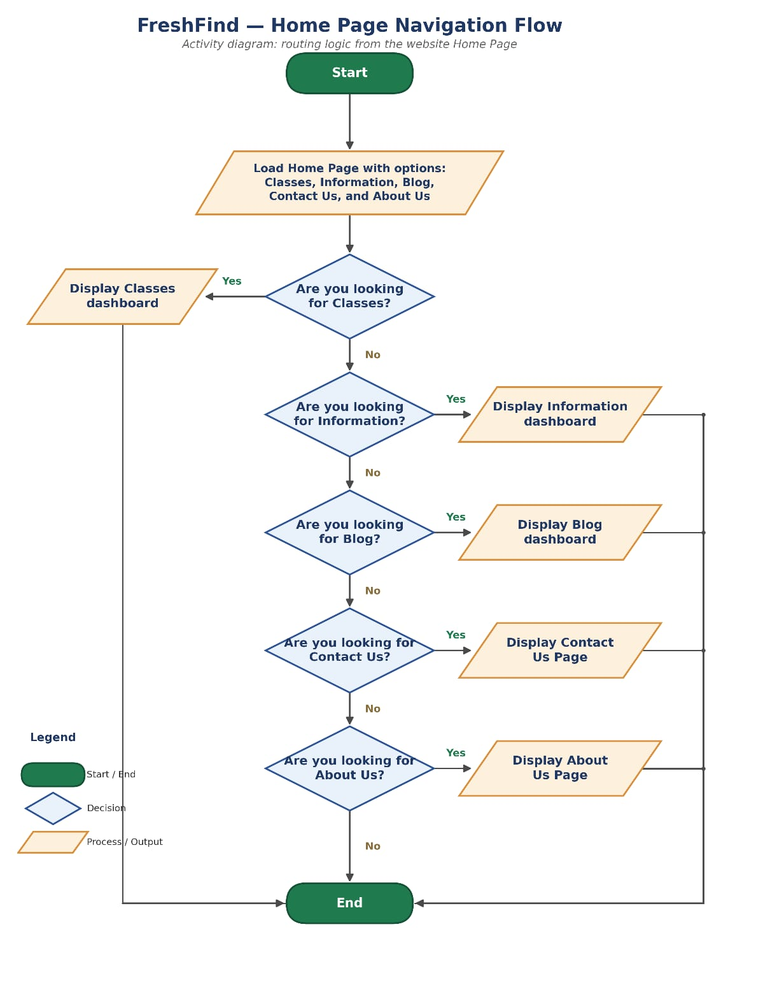
7. Section 3.5: Entity Relationship (ER) Diagram Description
An Entity Relationship Diagram (ERD) describes information required and/or the type of information that is stored in the database. For FreshFind, although data is stored in static JSON format rather than a relational database, the logical entity relationships are structured as follows:
- • Entity 'Market': Attributes: Market_ID (PK), Name, Area_Location, Operating_Days, Operating_Hours, Address, Map_Coordinates, Description, Thumbnail_Image.
- • Entity 'Produce': Attributes: Produce_ID (PK), Name, Category (Fruit/Veg/Herb/Dairy), Season, Description, Icon_Image.
- • Entity 'Bookmark_Note': Attributes: Note_ID (PK), User_Session_ID, Content_Type, Content_ID, Custom_Note, Date_Added.
- • Relationships: One Market offers Many Produce items (1:N); One Produce item can be found at Many Markets (N:M through Market_Produce junction).
Part 2: TechWiz 7 FreshFind Software Requirements Specification (SRS) Summary
Project Name: FreshFind ('Fresh All Along') | Theme: eGreen Basket | Category: Web Innovation Unleashed
SRS Version: 1.0
1. Key Functional Requirements
- Architecture: Single Page Application built with HTML5, CSS3, JavaScript, and ReactJS/AngularJS.
- Home Page: Hero banner, logo, quick search prompt, rotating featured markets showcase, and weekly seasonal picks.
- Market Directory: Filterable by neighborhood/area, day of week, and produce type. Sortable alphabetically, by proximity, or next open day.
- Market Detail View: Embedded Google Map, weekly schedule table, typical produce grid with icons/images.
- Produce Guide: Browsable produce categories, seasonal indicators, linked market availability.
- AI Chatbot: Floating cross-page widget using static pre-scripted FAQ JSON dataset with interactive suggested replies.
- Bookmarking System: Favorite markets/produce, session-only notes, formatted list export, and social media sharing.
- UI Features: Simulated visitor counter, real-time clock highlighting markets open 'right now', geolocation, breadcrumb navigation, and dummy login/signup modal.
2. Key Non-Functional Requirements & Constraints
- Strict Constraint 1: NO server-side data storage or dynamic server writing. All data is fetched client-side from static JSON/TXT files.
- Strict Constraint 2: Chatbot must NOT connect to live external AI backends/APIs. Must rely strictly on rule-based pre-scripted logic.
- Quality Attributes: High performance, WCAG contrast accessibility, 100% mobile responsiveness, tested via Google Lighthouse.
3. Project Deliverables Checklist
- Complete Project Report Document (Problem Definition, DFDs, ERDs, Specifications)
- Source Code ZIP file with ReadMe.doc listing all assumptions
- UI/UX Design Prototypes (Figma/Canva)
- Test Cases & Test Execution Report
- Mandatory Demonstration Video (.mp4 file)

